**Course Outcome to be mentioned which is mapped with this lecture topic.**

Co5 :- To perform different operations on videos.

**Reading Material of this lecture topic.**

**Animation**

Animation is the process of designing, drawing, making layouts and preparation of photographic sequences which are integrated in the multimedia and gaming products. Animation involves the exploitation and management of still images to generate the illusion of movement. A person who creates animations is called animator. He / she use various computer technologies to capture the still images and then to animate these in desired sequence.

Multimedia is the term used to represent combination of visual and audio materials gathered from various resources and then added into one single combination. A multimedia product can be sets of texts, graphic arts, sounds, animations and videos. Precisely, term multimedia is used to refer visual and audio materials into a single common presentation which can be played in a computer including CD ROM or digital video, internet or web technology, streaming audio or video and data projection system etc.

Modern entertainment industry i.e. film and television has gained new heights because of advances in animation, graphics and multimedia. Television advertisements, cartoons serials, presentation and model designs – all use animation and multimedia techniques.

Types of Animation

* Traditional animation (cell animation or hand-drawn animation)
* Stop motion animation (Claymation, Cut-outs)
* Motion Graphics (Typography, Animated logo)
* Computer animation
* 2D animation
* 3D animation

Multimedia refers to the term used to describe the combination of both audio and visual materials that have been gathered from different resources and then have been put into one single combination. A multimedia product can be set of [texts, animation, videos and even graphic arts](https://prayananimation.com/services.php). On the other hand, animation refers to the exploitation and management of still images to come up with an illusion of movement. Multimedia has a number of animation types used starting from **2D animation** up to computer-generated images. Consider the following types;

[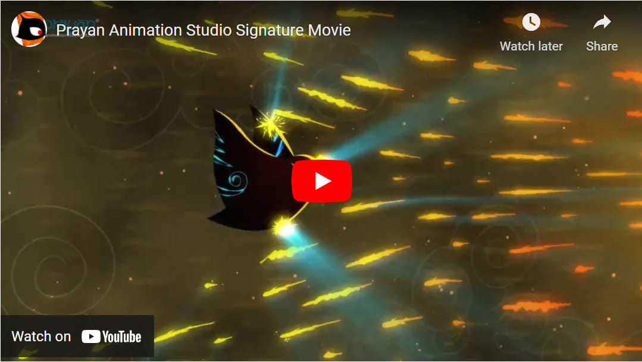](https://vimeo.com/240266601)

To begin with, 2D animation is the most common type of animation in multimedia. It is a vector-based animation that usually has two basic advantages. The animation is cheap to develop and has an ease of access characteristic. It does not consume a lot of time and resources. However, despite the stated advantages, one has to be equipped with [good understanding of keyframes and some related animation software’s](https://www.prayananimation.com/blog/how-to-choose-the-right-software-for-your-animation/).

Also, are the cel or the celluloid or rather traditional animation. This refers to the original hand-drawn animation that bears too many pictures on paper and they have to be photographed frame by frame to come up with the illusion of movement. This type of animation is best for individuals that like color pencils and the likes.

Additionally, another type of animation in the multimedia industry is the **stop motion animation**. This type of animation is similar to celluloid animation however in this type, clay models of the characters are used rather than hand drawings and other that one has to carefully manipulate them so that they can be produced. This animation has its own art which can’t be produced in other mediums.  Despite the beauty behind it, it is labour-intensive and consumes a lot of time.

Consequently, the motion graphics also find their way as the other **types of animation in the multimedia**. In this type, a visual effect mechanism involves the moving graphic elements such as texts or logos and it mostly uses the application software like after effects. Is s usually best for people who are mastering in advertising and design of movie opening titles.

[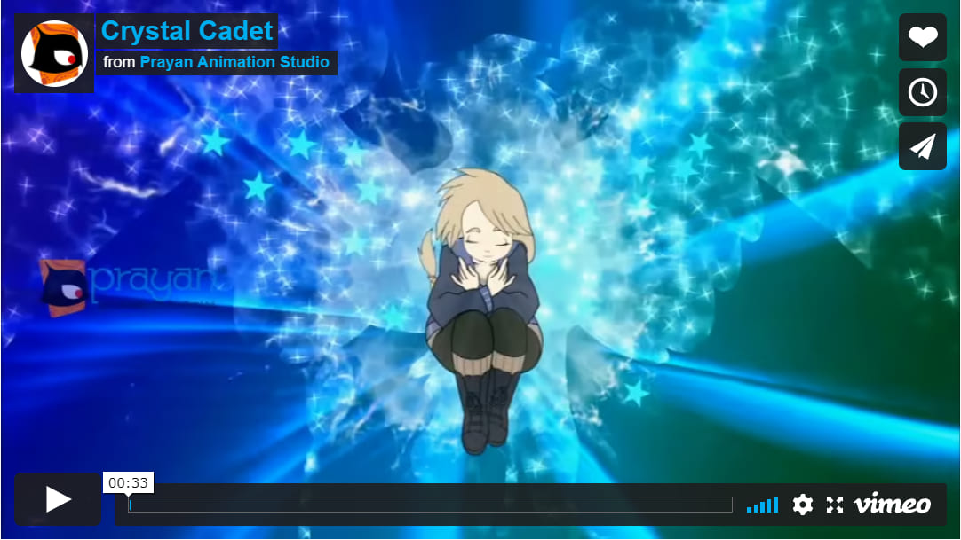](https://vimeo.com/258055218)

Last but not least, another type of animation is the 3D animation. It is also called computer-generated imagery. This type of animation is usually done by use of computers and computing software.  it has quite a defined procedure of developing them just like 2D animation, however, advanced. Once the animation character has been created, the setting or environment is now developed.

**Morphing**

Morphing is a familiar technology to produce special effects in image or videos. Morphing is common in entertainment industry. Morphing is widely used in movies, animation games etc. In addition to the usage of entertainment industry, morphing can be used in computer-based trainings, electronic book illustrations, presentations, education purposes etc. morphing software is widely available in internet.  
  
Animation industry looking for advanced technology to produce special effects on their movies. Increasing customers of animation industry does not satisfy with the movies with simple animation. Here comes the significance of morphing.  
  
The Word "Morphing" comes from the word "metamorphosis" which means change shape, appearance or form. Morphing is done by coupling image warping with colour interpolation. Morphing is the process in which the source image is gradually distorted and vanished while producing the target image. So earlier images in the sequence are similar to source image and last images are similar to target image. Middle image of the sequence is the average of the source image and the target image.  
  
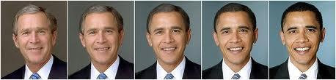

Morphing Techniques

Morphing techniques may be classified into two based on the ways to specify their features. They are mesh based methods and feature based methods. In mesh-based methods, features of the image specified by a non-uniform mesh. Feature based methods, features of the image specify as line segment or a set of points. Feature based methods are popular.

Morphing is an animation function which is used to transform object shape from one form to another is called Morphing. It is one of the most complicated transformations. This function is commonly used in movies, cartoons, advertisement, and computer games.

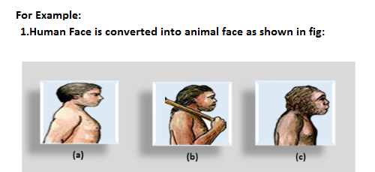  
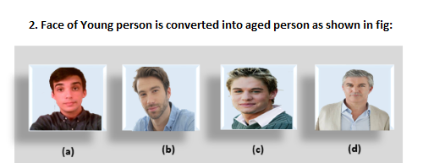

**The process of Morphing involves three steps:**

1. In the first step, one initial image and other final image are added to morphing application as shown in fig: Ist & 4th object consider as key frames.
2. The second step involves the selection of key points on both the images for a smooth transition between two images as shown in 2nd object.

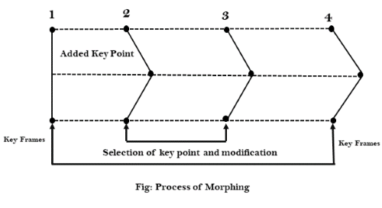

3. In the third step, the key point of the first image transforms to a corresponding key point of the second image as shown in 3rd object of the figure.

* ***Relevant Video links for this lecture topic.***
* [Multimedia animation | Multimedia in Hindi | Computer Science Teacher notes DSSSB/HSSC/KVS - YouTube](https://www.youtube.com/watch?v=8hJlgvPpcBk)
* ***Any web-link to be attached relevant to the topic.***

[What is Animation, Type Of Animation - 2D & 3D Animation (indiaeducation.net)](https://indiaeducation.net/animation/what-is-animation/#:~:text=Animation%20is%20the%20process%20of%20designing%2C%20drawing%2C%20making,still%20images%20to%20generate%20the%20illusion%20of%20movement.)

**TEXT BOOKS**

1. Tay Vaughan, “Multimedia making it work”, Tata McGraw-Hill, 2008.
2. Rajneesh Aggarwal & B. B Tiwari, “Multimedia Systems”, Excel Publication, New Delhi, 2007.
3. Li & Drew, “Fundamentals of Multimedia”, Pearson Education, 2009.

* **REFERENCE BOOKS**

1. Parekh Ranjan, “Principles of Multimedia”, Tata McGraw-Hill, 2007
2. Anirban Mukhopadhyay and Arup Chattopadhyay, “Introduction to Computer Graphics and Multimedia”, Second Edition, Vikas Publishing House.